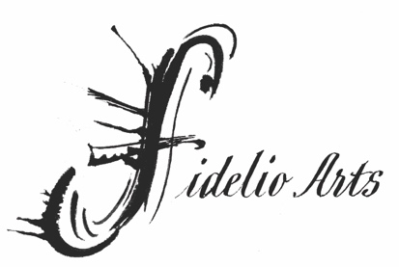
SUSANNA MÄLKKI
(BIOGRAPHY, 2022/23)

Susanna Mälkki is sought-after at the highest level with symphony orchestras and in opera houses worldwide. In her final season as Chief Conductor of the Helsinki Philharmonic Orchestra, she concludes a seven-year tenure with a distinctive dynamism and imaginative flair to her programming. In addition to a full season in Finland, she leads the Helsinki orchestra on tour to the prestigious Lucerne and Edinburgh festivals, New York’s Carnegie Hall and Washington’s Kennedy Centre this season.

Susanna Mälkki appears regularly with top orchestras throughout Europe and North America; Los Angeles Philharmonic, where she was Principal Guest Conductor from 2017 until 2022, Philadelphia Orchestra, The Cleveland Orchestra, the New York Philharmonic, Chicago Symphony Orchestra, the Boston Symphony, London Symphony Orchestra, the Münchner Philharmoniker, Wiener Symphoniker, Bayerischer Rundfunk and the Berliner Philharmoniker.

Equally in demand with major opera houses, past notable appearances include at the Opéra national de Paris, Teatro alla Scala Milan, the Wiener Staatsoper and The Metropolitan Opera. This season she visits The Royal Opera House, London with Saariaho’s Innocence, which Mälkki premiered in 2021 at the Festival d’Aix-en-Provence, and the Gran Teatre del Liceu, Barcelona for Puccini’s Il trittico. Future operatic titles include Debussy’s Pelléas et Mélisande and Beethoven’s Fidelio.

Recognised for her significant contribution to the art form, Mälkki was awarded the Pro Finlandia Medal of the Order of the Lion of Finland – one of Finland’s highest honours – in 2011. She has been awarded as Officier (2014) and Commandeur (2022) de l'Ordre des Arts et des Lettres of France and in January 2016 was made a Chevalier of the Légion d’honneur in France. She is a Fellow of the Royal Academy of Music in London and a member of the Kungliga Musikaliska Akademien in Stockholm. In October 2016 she was named Musical America’s 2017 Conductor of the Year, and in November 2017 she was awarded the Nordic Council Music Prize.

2022/23 season only

